1)Download the Auto IT and AutoIT editor and install both

2)Navigate to C:\Program Files (x86)\AutoIt3 and double click on Au3Info_x64.exe

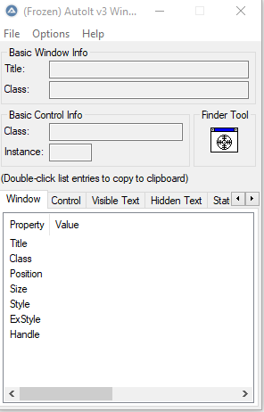

3)Double click on the exe file which is available on the location "C:\Program Files (x86)\AutoIt3\SciTE\SciTE.exe"

4)Drag and Drop the finder tool on the file upload element.

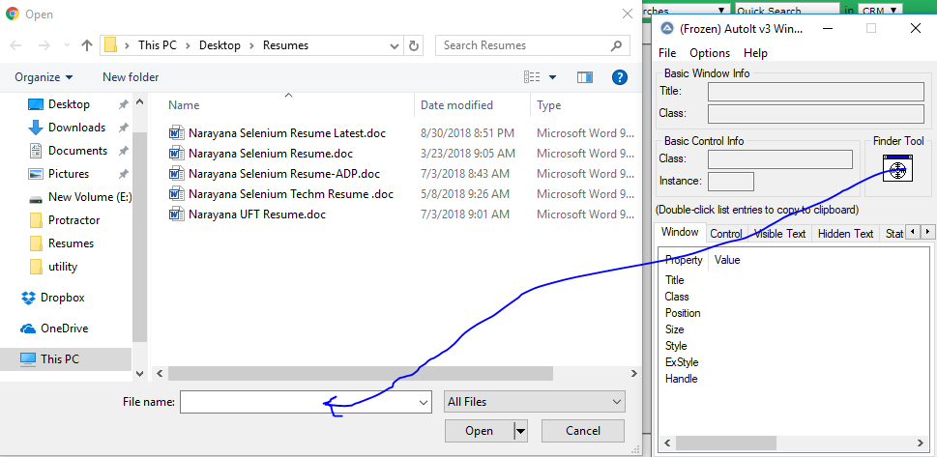

Once you drag the finder tool on the file name edit box you will see the below

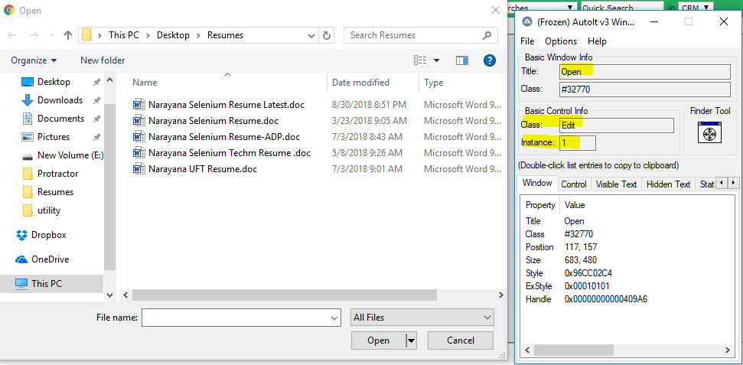

Go to Editor and write the below 2 lines of code highlighted

Syntax: ControlFocus("title","text","combination of class and class")

**ControlFocus("Open","","Edit1")**

**ControlSetText("Open","","Edit1","C:\Users\Narayana\Downloads\Architecture.png")**

Again drag the finder tool on the open button to get the elements

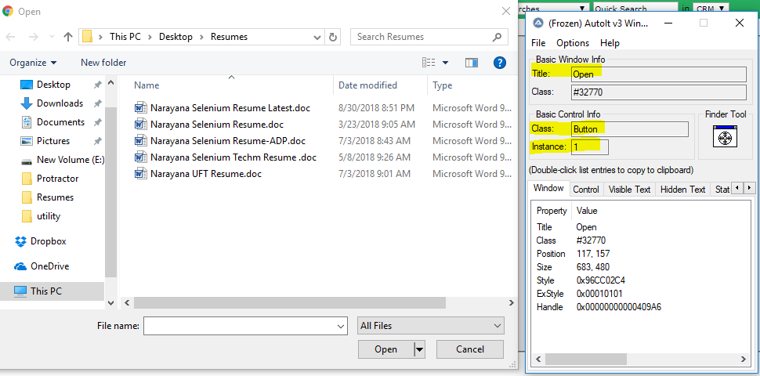

Once you drag on the open button write the below code in the editor

**ControlClick("Open","","Button1")**

Save the above 3 lines of code

Go to the saved file and right click on the saved file and click compile script (X64). It will create a .exe file

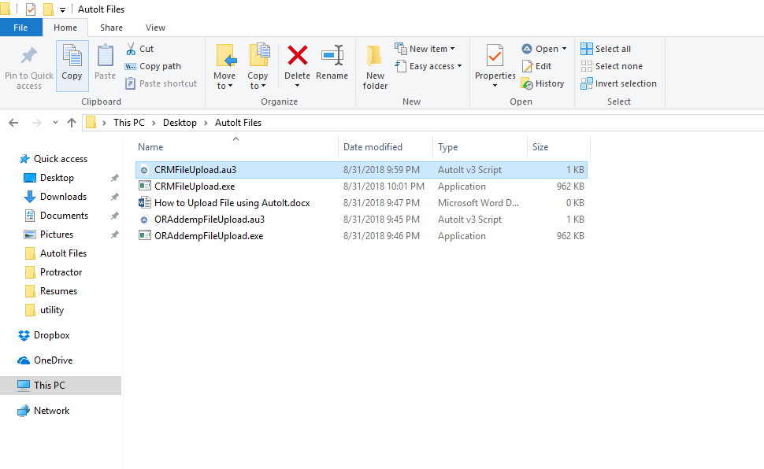

**Go to Seleium and write the below line code**

**Runtime.getRuntime().exec("C:\\Users\\Narayana\\Desktop\\AutoIt Files\\CRMFileUpload.exe");**